“GATE Group” Schedule
NGES Grade 1-4 Students

Thurs., Sept. 21 “Welcome Back”

Thurs., Oct. 19 “What is GATE?”

Thurs., Nov. 16 “Nobody’s Perfect”

Thurs., Dec. 21 “Bucket Fillers”

Thurs., Jan. 18 “The Dog Poop Initiative”

Thurs., Feb. 15 “Wilma Jean the Worry Machine”

Thurs., March 15 “More Than a Test Score”

Thurs., April 19 “Powerful Words for Your Toolkit”

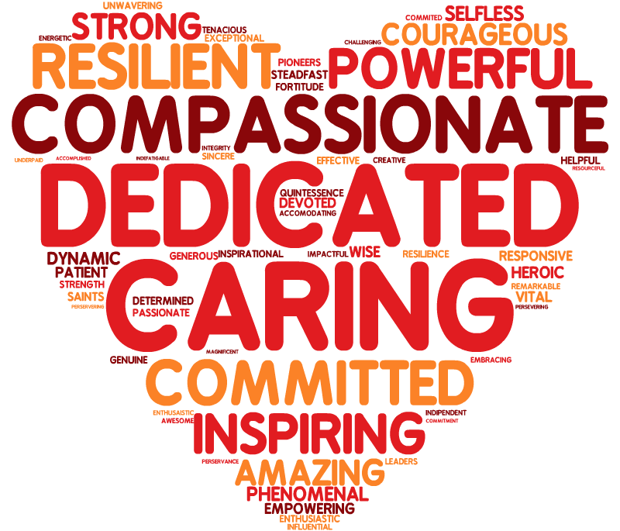

Thurs., May 17 “Celebrate Our Year”

